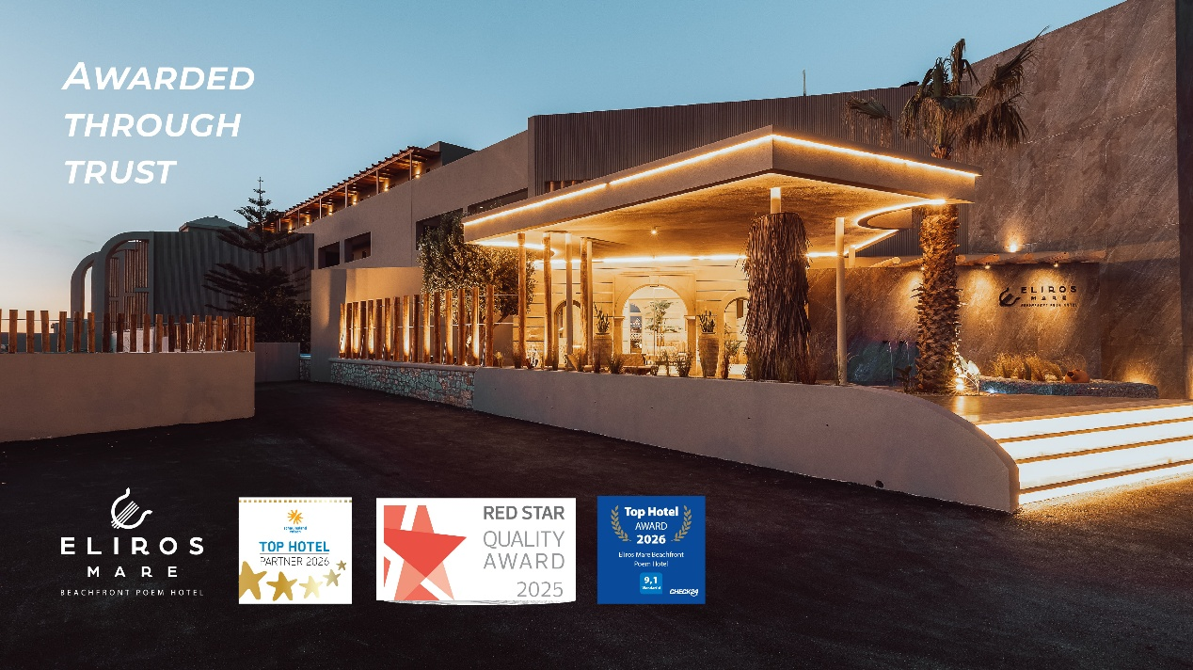
Eliros Mare Beachfront Poem Hotel Wins Multiple Prestigious Hospitality Awards
Eliros Mare Beachfront Poem Hotel is delighted to announce that it has been honored with three distinguished accolades: the Schauinsland Reisen Top Hotel 2026, the Red Star Quality Award 2025, and the Check24 Top Hotel Award 2026. These prestigious recognitions are based on outstanding guest feedback and are awarded only to hotels that consistently demonstrate excellence in quality, service, and overall guest satisfaction.
Receiving these awards highlights the hotel’s ongoing commitment to delivering exceptional hospitality and creating memorable experiences for every guest. It also reflects the dedication, professionalism, and passion of the entire team, whose continuous efforts ensure that each stay is truly remarkable.

Situated on the stunning beachfront of Crete, Eliros Mare Beachfront Poem Hotel combines refined comfort with authentic island charm, offering guests a unique and enriching holiday experience.

The management and team extend their sincere gratitude to their valued guests for their trust and support and remain committed to maintaining the highest standards of service in the years to come.

